SIMATS ENGINEERING (SAVEETHA SCHOOL OF ENGINEERING)
Department of Computer Science and Engineering

ASSESSMENT TOOL 3 – Comparative Analysis

Course Code: | CSA06 | Course Title: | Design and Analysis of Algorithms
 | CO4: Articulation (BL4, BL5)
Assessment Tool 3 – Comparative
Analysis
CO Assessed: |  | Assessment:
 | 10% of CIA
 |  |  | 100
Weightage: |  | Total Marks:
 | Solve optimization problems using dynamic programming and greedy strategies.
CO4 Statement:
Student Name: | Y. Veera Reddy | Reg. No.: | 192211898
 | B Tech – CSE
 |  |  | 24-08-2026
Section / Batch: |  | Date:

Instructions to Students
- Answer the following question. Total Marks: 100.
- Analyze the given questions thoroughly before answering.
- Compare multiple aspects such as methods, results, advantages, and limitations clearly.
- Critically evaluate the strengths, weaknesses, and implications with proper justification.
- Present meaningful insights, interpretations, and well-supported conclusions from the comparisons.

Question Type | Focus Area | Questions
Comparative Analysis | Comparative analysis of Dynamic Programming and Greedy algorithms for optimization problems. | Q1

SECTION A – Comparative Analysis

Q1. Huffman Coding vs Container Loading (Greedy Comparison)
Given frequencies and weights, solve using Huffman Coding and Container Loading. Compare greedy selection criteria. Analyze optimality. Evaluate computational complexity. Discuss applications. Generate insights on greedy methods.

Code of Conduct
I _Y. Veera Reddy / 192211898 (Name / Reg No) certify that this submission is my original work and that I have adhered to the guidelines specified for this assessment. I understand that any violation of academic integrity rules will result in disciplinary action.
Signature of the Student: Y. Veera Reddy_

RUBRICS FOR CALCULATION

Faculty In-charge | Course Coordinator | Head of Department

 |  | Comparative Analysis
Criteria | Weightage | Level 4 (Exemplary) | Level 3 (Proficient) | Level 2 (Developing) | Level 1 (Beginning)
Selection of Studies/Parameters | 20% | Selects highly relevant and diverse studies with  well-defined comparison  parameters | Selects relevant studies with minor  gaps in parameter definition | Limited or partially relevant selection | Poor or inappropriate  selection of studies
Comparison & Differentiation | 25% | Clearly compares multiple aspects  (methods, results, limitations) with strong differentiation | Good comparison with minor gaps | Basic comparison with limited depth | No clear comparison; mostly descriptive
Critical Evaluation | 25% | Critically evaluates strengths, weaknesses,  and implications with strong justification | Provides evaluation with some justification | Limited evaluation; lacks depth | No critical evaluation provided
Synthesis & Insight Generation | 20% | Generates meaningful insights and conclusions from comparisons | Some insights derived from comparison | Limited or unclear insights | No insights generated
Clarity | 10% | Information is clearly presented  (tables/figures) with logical structure | Generally clear with minor issues | Presentation lacks clarity or structure | Poor presentation and difficult to understand

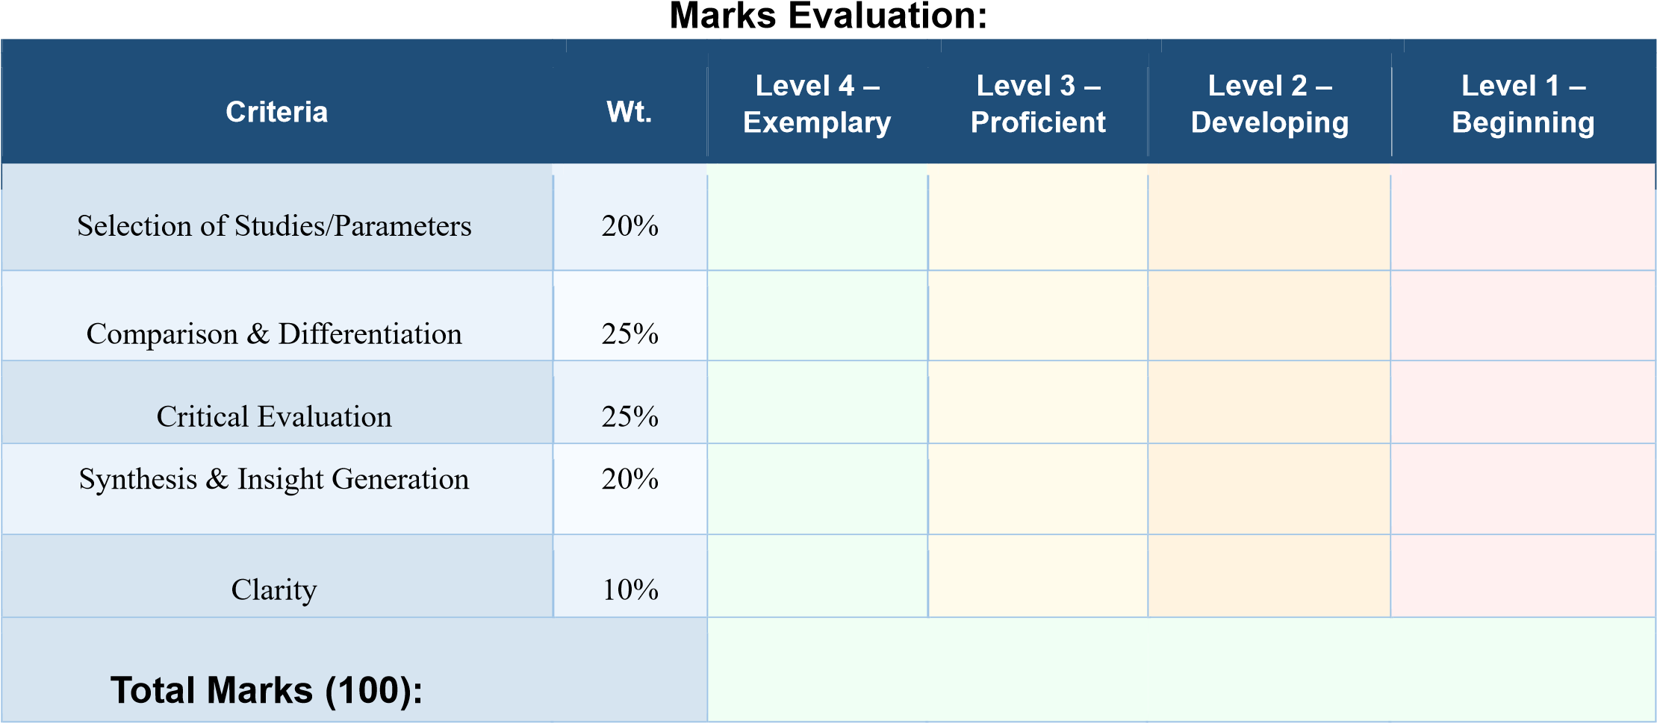

Name: | Name: | Name:
Signature: _______________ | Signature: _______________ | Signature: _______________
Date: ___________________ | Date: ___________________ | Date: ___________________

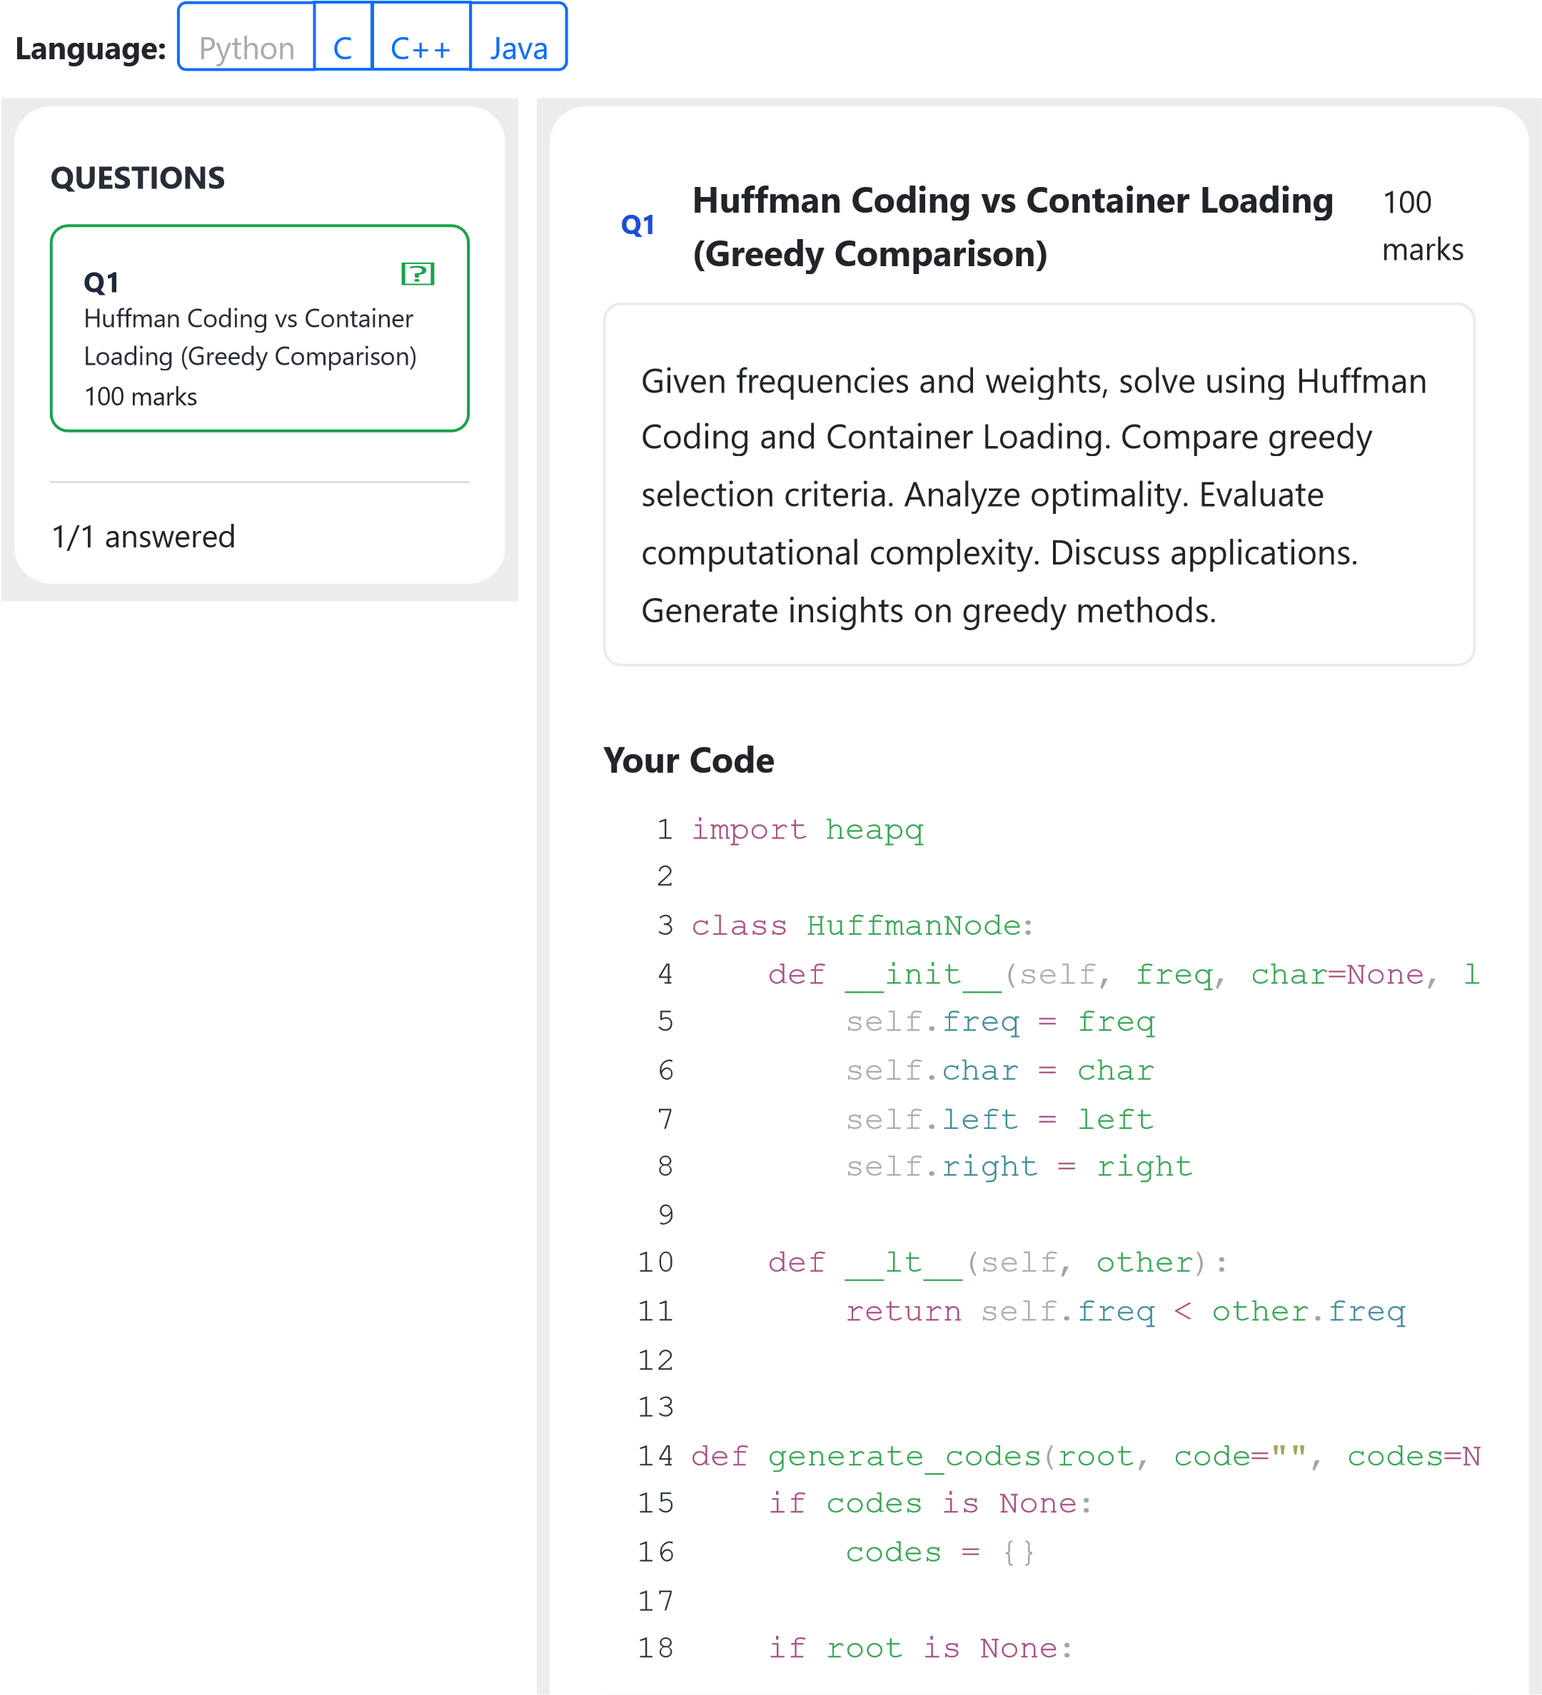

19 return codes
20
- # Single character case
- if root.char is not None:
- codes[root.char] = code if code
e
- return codes
25
- generate_codes(root.left, code + "0",
- generate_codes(root.right, code + "1"
28
29 return codes
30
31
- def huffman_coding(chars, frequencies):
- heap = []
34
- for char, freq in zip(chars, frequenc
- heapq.heappush(heap, HuffmanNode(
37
- while len(heap) > 1:
- left = heapq.heappop(heap)
- right = heapq.heappop(heap)
41
- merged = HuffmanNode(
- left.freq + right.freq,
- left=left,
- right=right
- )
47
48 heapq.heappush(heap, merged)
49
- root = heap[0]
- codes = generate_codes(root)
52
- total_cost = sum(
- freq * len(codes[char])
- for char, freq in zip(chars,
freq
- )
57
58 return codes, total_cost
59
60
61 def container_loading(weights, capacity):

62 | selected = []
63 | total_weight = 0
64  65 | indexed_weights = sorted(
66 | enumerate(weights, start=1),
- key=lambda x: x[1]
- )
69
70 for index, weight in indexed_weights: 71 if total_weight + weight <= capac
- selected.append((index, weigh
- total_weight += weight
74
75 return selected, total_weight
76
77
78 def main():
79
80 print("===== HUFFMAN CODING VS CONTAI
81
82 n = int(input("Enter number of symbol
83
- chars = []
- frequencies = []
86
87 print("Enter symbol and frequency:") 88 for _ in range(n):
89 parts = input().split()
90
- if len(parts) != 2:
- print("Invalid input. Enter
a
- return
94
- char = parts[0]
- freq = int(parts[1])
97
- chars.append(char)
- frequencies.append(freq)
100
101 codes, total_cost = huffman_coding(ch
102
- print("\n--- Huffman Coding ---")
- print("Symbol\tFrequency\tCode")
105
106 for char, freq in zip(chars, frequenc 107 print(f"{char}\t{freq}\t\t{codes[
108
109 print("Total weighted code length:",
110
111 m = int(input("\nEnter number of cont
112

113 weights = list(map(int, input("Enter
114
- if len(weights) != m:
- print("Number of weights does not
- return
118
119 capacity = int(input("Enter container
120
121 selected, total_weight = container_lo
122
- print("\n--- Container Loading ---")
- print("Capacity:", capacity)
- print("Selected containers/items:")
126
- for index, weight in selected:
- print(f"Item {index}: weight = {w 129
- print("Total loaded weight:", total_w
- print("Unused capacity:", capacity -
132
- print("\n--- Greedy Comparison ---")
- print("Huffman Coding:")
- print("Greedy criterion = combine the
136
- print("\nContainer Loading:")
- print("Greedy criterion = select the
139
- print("\nComplexity:")
- print("Huffman Coding: O(n log n)")
- print("Container Loading: O(n log n)"
143
- print("\nConclusion:")
- print("Both algorithms use greedy sel
- print("Huffman Coding produces an opt
- print("Container Loading is optimal f
- print("but greedy selection is not op
149
150
- if __name__ == "__main__":
- main()
153
- Comparative Analysis: Huffman Coding vs.
- 1. Greedy Selection Criteria
- * Huffman Coding: The greedy criterio 157 * Container Loading (Lightest-First):
158
- 2. Analysis of Optimality
- * Huffman Coding: This algorithm is g
- * Container Loading: The "lightest-fi 162

